Veterans Benefits Administration

Department of Veterans Affairs

Custom Federal Regulations Service™

Book B—Adjudication

Code of Federal Regulations

Title 38, Part 3

Jonathan Publishing

Copyright © 2006 Jonathan Publishing

Need Assistance?

Questions concerning missing supplements, need for additional books, and other distribution list issues for this loose-leaf service should be directed to:

Department of Veterans Affairs
Veterans Benefits Administration
Administration
Mail Code: 20M33
810 Vermont Avenue, N.W.
Washington DC 20420
Telephone: 202/273-7588
Fax: 202/275-5947
E-mail: coarms@vba.va.gov

Questions concerning the filing instructions for this loose-leaf service,
or the reporting of substantive errors in the text,
may be directed to:

Jonathan Publishing
855 Yorks Crossing
Driftwood TX 78619
Telephone: 512/858-1225
Fax: 512/858-1230
E-mail: jonpub@austin.rr.com
Internet: http://www.jonpub.com

Copyright © 2006 Jonathan Publishing

Important Information
about this
Looseleaf Regulations Service

Users of this looseleaf service should read this information in order to better understand how the regulations are presented, indexed, and supplemented. It is particularly important to understand the supplementing process so that errors in filing supplements do not render the book useless.

Presentation. Each page contains information in six different locations, as indicated on this sample page:
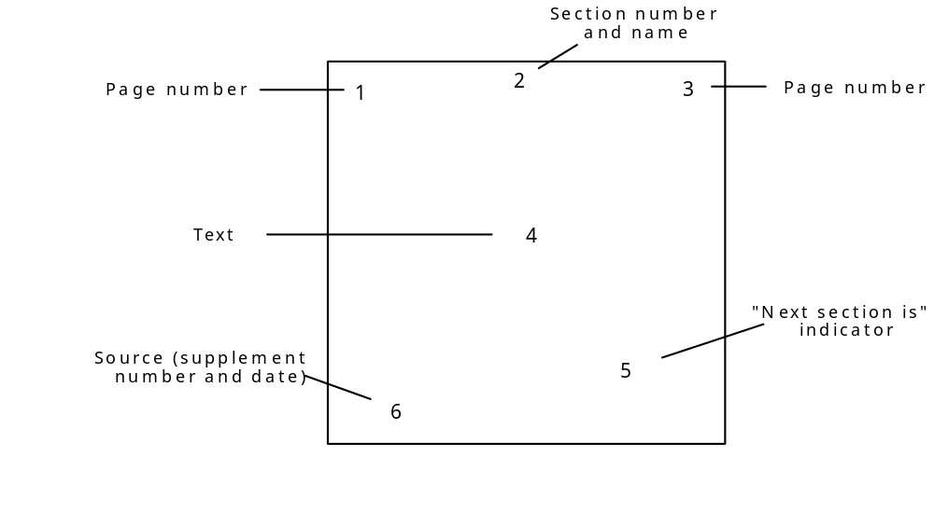
¨, Æ — Page numbers. Page numbers have three parts:

(1) the section number (e.g., §25.30),
(2) a hyphen, and
(3) the page number within that section (e.g., 25.30-4).

The page number appears in both the upper left-hand corner and the upper right-hand corner of the page. If there is only one section on the page, these numbers will be identical. However, if the page contains two or more short sections (e.g., §25.62 and §25.63), then the number in the upper left-hand corner indicates the first section on the page (e.g., 25.62-1) while the number in the upper right-hand corner indicates the last section on the page (e.g., 25.63-1).

The page number(s) will always tell you what section(s) are on that page, so that if you know the section number you can find that section simply by flipping through the pages until you come to the appropriate section number.

≠ — Section number and name. In the top center of each page you will find the section number and the title of that section. This is useful for sections that are two or more pages in length because you can glance at the top center and know the number and name of the section you are reading.

Ø — Text. The text of the regulation occupies the bulk of the page. The text is as it appears in the official government publication, the annual bound volume of the Code of Federal Regulations, as amended by final rules published in the daily Federal Register. By using the looseleaf format, we are able to make changes in response to amendments as they appear in the Federal Register and send you those replacement pages in a very short time. Thus these materials remain current at all times. Relying on the bound volume of the Code of Federal Regulations can be hazardous since it is three to four months out of date when initially published, and sixteen to seventeen months out of date when replaced a year later. Reading the Federal Register every day in order to update the CFR can be a time-consuming and tiresome process. Our service does all the preparatory work for you—leaving you free to read and apply the regulations.

∞ — “Next Section Is.” For whatever reasons, promulgating agencies do not always number their regulations consecutively (e.g., 25.1, 25.2, 25.3, 25.4). Sometimes the skips are at regular intervals (e.g., 25.10, 25.15, 25.20, 25.25) while other times the skips are just at the end of subparts (e.g., 25.74, 25.75, 25.76, 25.100). In any case, when you move directly from §25.3 to §25.55 it is not possible to know if this is the actual order of the regulation numbers, or if there are missing pages. To solve this problem—and to provide you with a means of determining at any time if your set is complete—whenever there is a skip in section numbers we tell you what the next section number should be. On the last page of the preceding section, in the place on the page indicated by the “∞” on the diagram, you will find the words “Next Section is” followed by a section number. That tells you what the next section number should be. If there is no “Next Section is” reference, then the next section is in normal sequence.

± — Source. In the lower left-hand corner of every page you will find an entry that looks like one of these two formats:

(Original 4/30/92) or (Reprint 1996) or (No. 24 11/25/96)

One of the first two forms is on every page when the book is initially published. It means that the original book was issued on 30 April 1992, or reprinted in 1996.

The second form is used for replacement pages sent to you because an amendment (or a new regulation) has been published. It indicates the number of the supplement in which it was transmitted (e.g., No. 24), and the date of preparation of that supplement (e.g., 25 November 1996). This allows you to check your set for accuracy against our master set by calling us at any time. It also allows you to know exactly when certain changes in the regulations were made, and whether you have the appropriate changes filed in your book.

Indexing. This looseleaf service has two indices.

Index 1 is arranged by Code of Federal Regulations section number and presents the contents in the order in which they appear in the Code of Federal Regulations. Since our page numbering system uses the section numbers, this index serves primarily as a table of contents for the book.

Index 2 is arranged by the titles of the sections, and gives the titles of all sections in alphabetical order. Thus if you were interested in the subject of burial benefits (forfeiture), you could look under that subject in the Index by Section Title preceding Part 1 and find the entry alphabetically. You would then turn to page 3.1609-1 to obtain the required information.

Supplements. By far the most important feature of this service is the supplement process. Supplements are prepared at the end of each month during which at least one final rule modification in the parts of Title 38 included in this book occurs. If no such change occurs in a particular month, then no supplement is provided for that month. The supplement will contain the following parts:

1. Title page
2. General instructions
3. Filing instructions
4. Highlights

The title page will tell you to which Book (A through H) the supplement applies, so if you have more than one of our looseleaf services you will have no problem in identifying the one addressed by a particular supplement.

The general instructions explain how the supplement process works in more detail than provided here, and gives specific guidance for making the changes.

The filing instructions tell you exactly which pages to remove and which pages to add.

The highlights section gives a brief summary of the nature of each change made by the pages in that supplement so that you will be aware of significant alterations in the regulations that might affect your responsibilities.

Further instructions concerning supplements will be found in the following section. The most important piece of information about the supplement process, however, is the instruction to check the Supplement Filing Record to make certain that all prior supplements have been properly filed before beginning to file the current supplement. This will prevent filing materials out of order. Nothing will wreck a book of looseleaf regulations faster—and more irrevocably—than filing a later supplement before an earlier one. What you have likely done in such a case is to take out good, current material and insert old, outdated material. To avoid this error, simply check the Supplement Filing Record before filing each supplement. If there are missing
supplements, call the VA for replacements and do not file the current supplement until those back issues are received and filed in proper order.

Supplement frequency. Beginning on 1 August 1995 (as noted above) supple-meanest are prepared at the end of every month during which at least one final rule modification to the parts of Title 38 included in this book occurs.

sources of assistance can be found on page B-2

Note: All references in the text of the regulations to Title 38, United States Code, are to redesignated section numbers as established in 1991 by P.L. 102-40, P.L. 102-83, and other sources, as compiled by the Office of General Counsel, Department of Veterans Affairs.

Instructions for Filing Supplements

Book B—Adjudication

This compilation of federal regulations affecting the Veterans Benefits Administration is provided for persons requiring easy access to current regulatory information. By using the looseleaf format, changes in the form of final rules published in the Federal Register can be incorporated at regular intervals following publication. You will receive supplements on a periodic basis reflecting new regulations and amendments to existing regulations. Filing instructions will provide you with an easy to follow routine for removing old pages and inserting new pages. Once such supplemental materials are filed, the set will reflect the current regulatory regime at that time.

To ensure accuracy and timeliness of your materials, it is important that you follow these simple procedures:

1. Always file your supplemental materials immediately upon receipt.

2. Before filing, always check the Supplement Filing Record (page B-5) to be sure that all prior supplements have been filed. If you are missing any supplements, contact the Veterans Benefits Administration at the address listed on page B-2.

3. After filing, enter the relevant information on the Supplement Filing Record sheet (page B-5)—the date filed, name/initials of filer, and date through which the Federal Register is covered.

4. If as a result of a failure to file, or an undelivered supplement, you have more than one supplement to file at a time, be certain to file them in chronological order, lower number first.

5. Always retain the filing instructions (simply insert them at the back of the book) as a backup record of filing and for reference in case of a filing error.

6. Be certain that you permanently discard any pages indicated for removal in the filing instructions in order to avoid confusion later.

Reserved

